E-COLLAR TACTICAL K-9 400
USER MANUAL
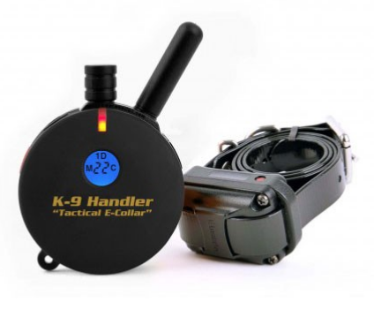

Please read this user manual carefully before use.

The E-Collar Tactical K9-400 is the smallest rechargeable collar on the market with a range of up to 1200m and offering sound, vibration, 100-level pulse and Booster functions. The ergonomic transmitter and well-shaped receiver ensure comfortable wearing for the animal itself as well as handling for the owner. The transmitter completely hides in the palm of your hand during training and the control buttons fall directly under your fingers. The collar features very intuitive operation without the need to constantly check the settings.

MAIN FUNCTIONS
- Range 1200 m
- Suitable for dogs from 2 kg and up
- Functions sound, vibration (Tapping Sensation), pulse in 100 levels and Booster
- Waterproof receiver and transmitter
- Receiver submersible to a depth of 12.5 m
- Unique design of the transmitter fits in the palm of your hand
- Floating transmitter
- Lost Transmitter Beep function
- Simple operation
- LCD display
- Night tracking
- 3 selectable training modes
- Expandable for training 2 dogs
- Extra comfortable adjustable strap included

DESCRIPTION - TRANSMITTER
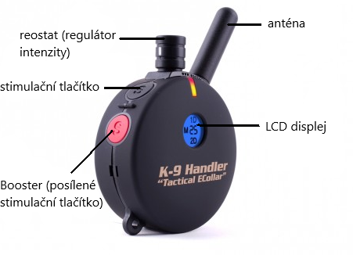
FRONT SIDE

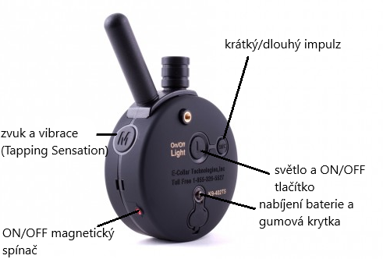
BACK SIDE

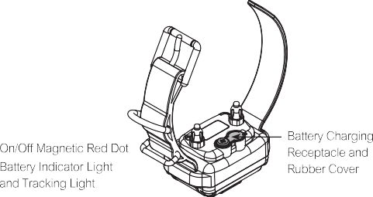
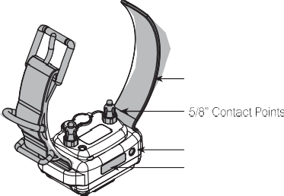
DESCRIPTION - RECEIVER

CHARGING THE BATTERIES

Indicator Light is blinking "Green" under normal operation.
solid "Red" when stimulation is applied.
blinking "Red" when recharging is required.

Do not allow the batteries to get hot or be fully discharged, store at room temperature and 50% capacity charge.

Transmitter Battery Charging Collar Receiver Battery Charging
Receptacle and Rubber Cover Receptacle and Rubber Cover
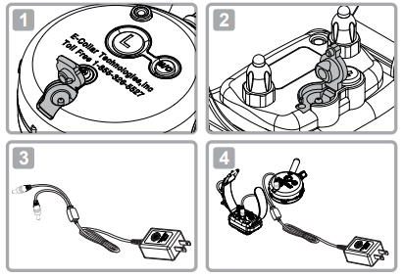
The indicator light will turn solid red during charge cycles and turn green if it s fully charged, (approximately 2 hours).

Please add this about the batteries:

Your e-collar is outfitted with Li Polymer batteries which requires specific care to assure longevity. It is best not to let the battery be fully discharged and if it does, recharge immediately or irreversible damage may occur. Keep the units away from extreme heat and cold temperatures.

TURNING YOUR E-COLLAR ON/OFF
To turn the Collar Receiver On or Off
Place the small red dot on the Transmitter to the small red dot on the Collar Receiver.
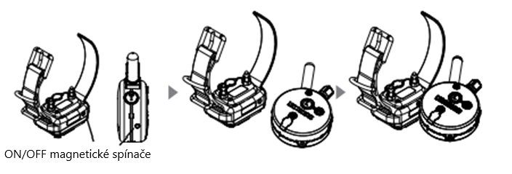
To turn the Transmitter On or Off :

Press the "L" button for more than 2 second.
If the Transmitter is turned on, a short press of the "L" button will activate the tracking light of the collar receiver. Press and hold for 2 seconds to turn Transmitter off.

Holding the Transmitter
To obtain the maximum range hold the transmitter like the torch on the Statue of Liberty. Keep the antenna away from your body or fingers at all times, touching the antenna will greatly reduce the range.

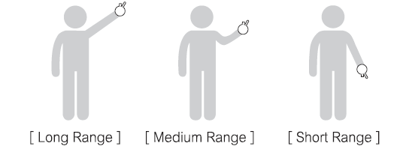

)

CORRECTLY FITTING COLLAR

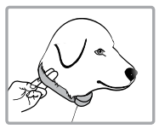
Important: Correct fitting and positioning of the collar with the receiver is important for its effective functioning. The contact pins must be in direct contact with your dog's skin, on the underside of the neck.
The collar must be fitted correctly to ensure safe and proper effectiveness.

- Each electronic collar must fit snugly against the skin. The electrodes must fit all the way to the skin under the fur, but must not pinch.
- If the collar is too loose, the stimulation will not work properly as the electrodes will not make proper contact with the animal's skin. If the dog does not respond to stimulation, always check that the electrodes are tight against the skin.
- During training or running, a collar that is too loose can cause irritation to the skin on the animal's neck. A properly fitting collar will help prevent irritation from occurring.
- The correct fit of the collar is important. It must be fitted so that it does not strangle the dog and so that it can breathe normally. The collar must never prevent the animal from breathing.
- The receiving collar must be placed correctly in the centre of the animal's neck.

To ensure maximum effect and safety of your dog, check the placement of the collar, its sufficient tightening and the correct placement of the electrodes. Also check the skin where the electrodes touch for any rash or irritation. If this is the case, put the collar on for shorter periods of time or consult your vet. Do not attach a leash to the collar.
The collar should not be worn continuously for more than 12 hours a day (this is a recommendation for all collars, even non-electric ones). If irritation occurs, remove the collar until all signs of irritation have disappeared.

LCD DISPLEY
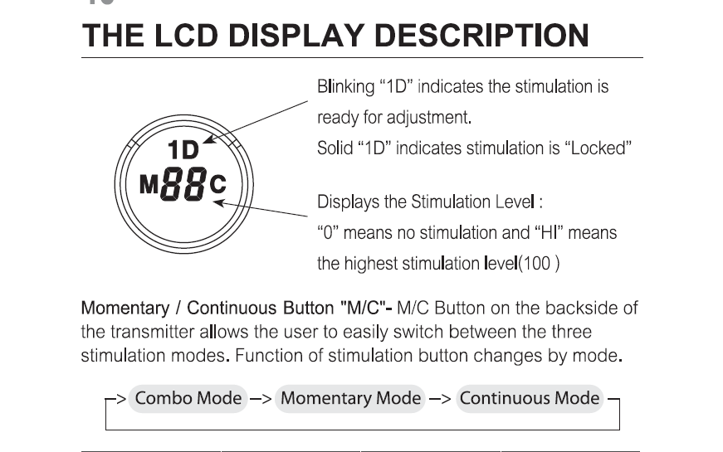

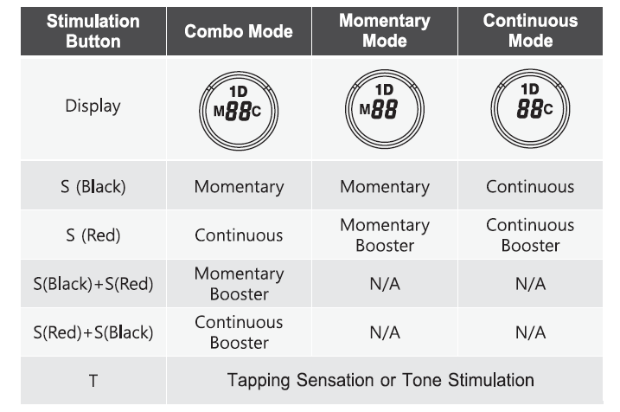

BUTTON FUNCTIONS
Momentary Stimulation
Sends a single pulse of stimulation at the set level when you press stimulation button.
Continuous Stimulation
Sends pulses of stimulation for as long as the button is pressed, timing out after 10 seconds (this is a safety feature designed to prevent accidental over-stimulation of your dog). The stimulation can be increased or decreased while the button is being pressed.
Tapping Sensation
Vibration specifically designed to distract your dog, great for deaf dogs and stimulation sensitive dogs.
Tone followed by Stimulation (Pavlovian Conditioning)
After 1.2 seconds of tone, the collar will administer continuous stimulation for as long as the button is pressed (up to 10 seconds). Release before 1.2 seconds for tone only.

Stimulation Button S (Black)
By pressing the button, the collar sends a short or long pulse depending on the set mode.

Stimulation Button S (Red)
Booster function. A single push of a button increases stimulation up to several levels.

BUTTON M
Tapping Sensation function and sound.
The default setting is vibration (Tapping Sensation).
To switch between functions, press the "L" and "M" buttons simultaneously. The stimulation level must be at level 0.
- 1x beep and "A" icon - sound followed by a pulse
- 2x beeps and "T" icon - Tapping Sensation (vibration)

L BUTTON
Lighting function and ON/OFF button.
Pressing the L button turns on the tracer light.
OFF -> Flashing -> Steady -> OFF

HOW TO FIND THE PROPER STIMULATION LEVEL
Rotating clockwise increases the stimulation level, and rotating counter-clockwise lowers the stimulation level. It is highly recommended that the user practices changing levels and modes before putting the collar receiver on a dog. Setting the correct stimulation level for your dog is very important, To set your "conditioning" stimulation level, correctly put the collar receiver on your dog (see page 9 for instructions). Let the dog get used to the collar receiver for a couple of hours, While watching your dog, turn the level to "0" and press the continuous stimulation button, Slowly turn the stimulation up at a rate of approximately 2-3 levels per second, When your dog first perceives the stimulation, usually between 5 and 20, release the button. This is your "conditioning" stimulation level. You may need to increase the "conditioning" level a few levels to get your dog to respond at first, some dogs are more stubborn and need more stimulation, The boosted level is typically 5 to 20 levels higher than the "conditioning" level.
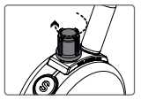

IMPORTANT TIP FOR TRAINING
The electronic collar should only be used to support commands that your dog already knows. It is not a substitute for regular training, but only as a tool for better communication with your dog.
For best results, use the least amount of stimulation to achieve obedience. A calm and consistent approach to training always leads to better long-term results.
For aggressive dogs, we recommend consulting a professional trainer first about using an electronic collar.
You can find various videos on YouTube showing different techniques for using an electronic collar.
Good luck with your training!

LOCK/UNLOCK THE STIMULATION LEVEL

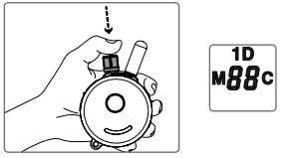
How to Lock/Unlock the Stimulation Level Set the desired stimulation level and then press on the top of the stimulation dial until you see "1D" light up on the top portion of the LCD display. Flashing "1D indicates unlocked stimulation and Solid '1D indicates locked stimulation.

If the stimulation level does not change when you rotate the stimulation knob, you have successfully locked the stimulation level.

To unlock the stimulation level simply press the stimulation knob again and it will unlock the stimulation level.

HOW TO SET THE BOOST
Boosted Stimulation adds the set boost level to the stimulation level, great for those situations when your dog does not respond to the "conditioning" level. Determining the Boosted stimulation level is a little more difficult than stimulation level setting due to the wide differences in temperaments and stimulation tolerance among the many breeds of dogs. On average, it is normally 5 to 20 levels higher than the "conditioning" level. It is important to have it set high enough to get the desired response from your dog.
1. Change the mode to Momentary Mode. (Press M/C buttan untl "M" is displayed)
2. Change the intensity level to "0".
3. Press S(Black) button for more than 5 seconds.
4. The intensity level will change from "0' to a flashing '1'.
5. Rotate the dial to the desired boost level (1 to 60). 6. Press S(Black) button again to save and exit the boost level changing mode.

FUNKCE LOST TRANSMITTER BEEP (ZTRACENÉ ZAŘÍZENÍ)
Your electronic collar allows the user to set a 6-hour timer. After 6 hours, the transmitter will beep and you can find the device again if it is lost.
How to activate the timer?
1. Turn the intensity control to "0".
2. Press the stimulation button S (black) and the light button (L) at the same time.
3. The transmitter will beep 3 times.
4. The timer is set.

To turn off, turn the intensity control back to "0". Press the stimulation button S (red) and the light button (L) at the same time. The transmitter beeps twice and the timer is deactivated.

GUARANTEE
Declaration of conformity, warranty and post-warranty service
The instrument has been approved for use in EU countries and is therefore CE marked. All necessary documentation is available on the importer's website, on request from the importer and at the importer's shop. Changes to technical parameters, features and typographical errors are subject to change.

The address where the declaration of conformity and the current instructions can be found (download tab):
https://www.elektro-obojky.cz/vycvikove-obojky/e-collar-tactical-k9-400

Warranty and post-warranty repairs are provided by the importer:
Reedog Ltd,
Sedmidomky 459/8
Prague
101 00
Hotline: 216 216 106
Email: info@elektro-obojky.cz

